PL/SQL programming
Solution:
Exercise 1: Control Structures
Scenario 1:
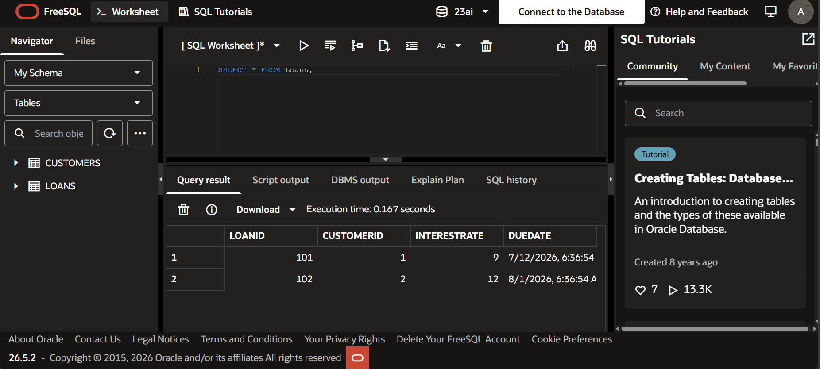
Scenario 2:
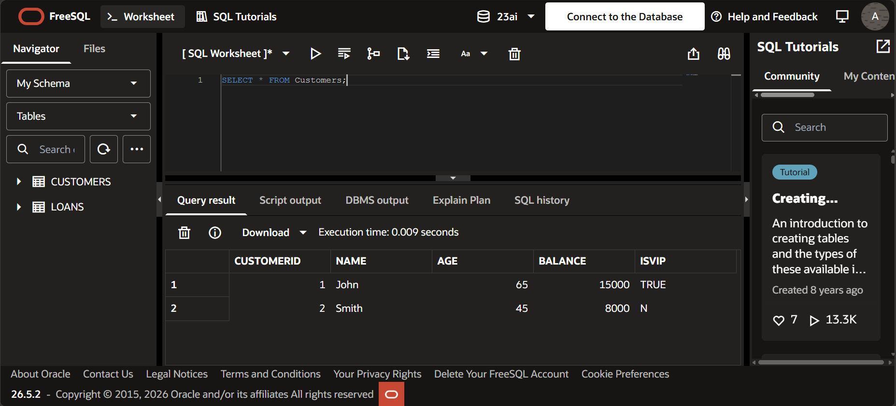
Scenario 3:
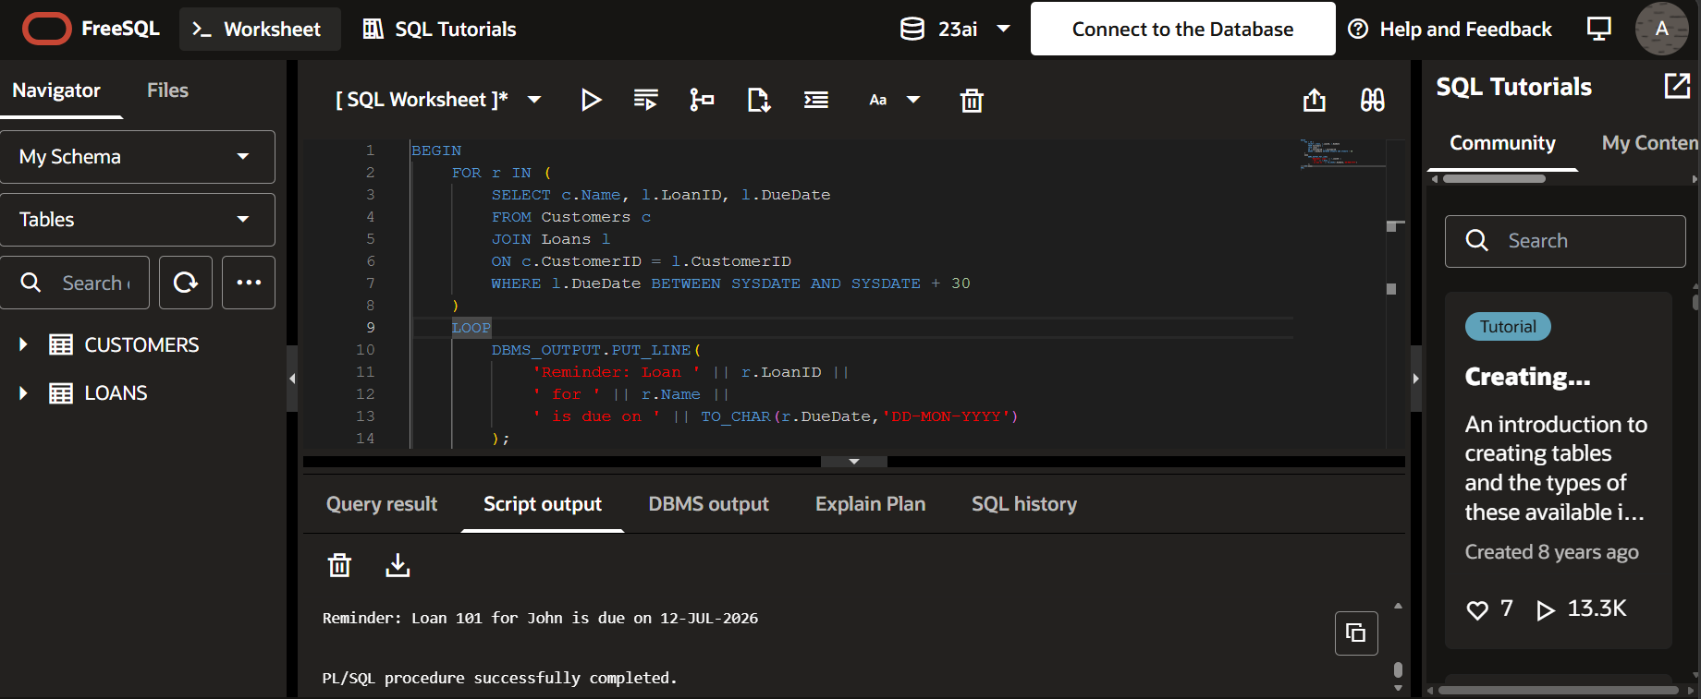
Exercise 3: Stored Procedures

Scenario 1:
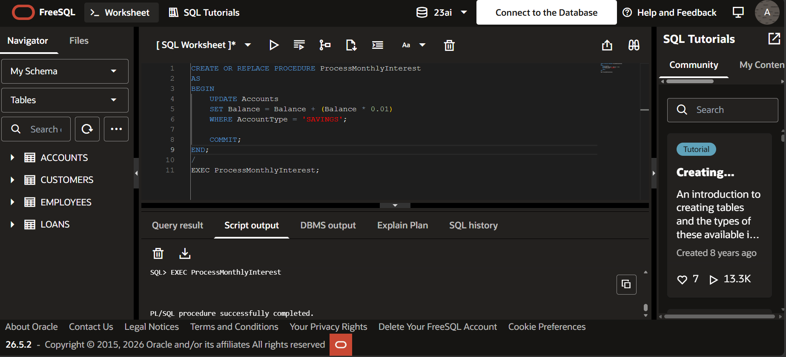
Scenario 2:
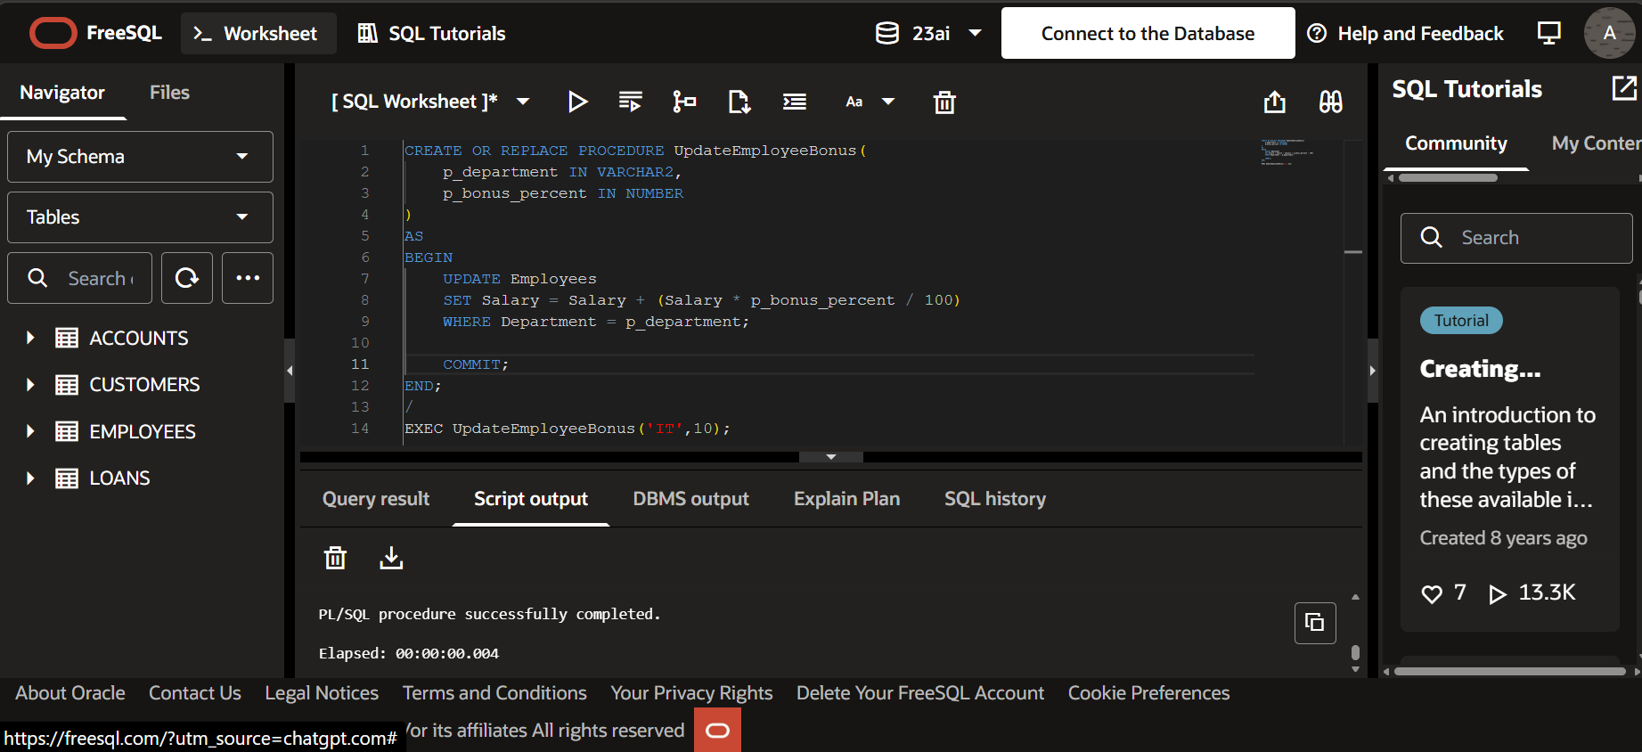
Scneario 3:
